Mediator
(Behavioural)

In software development, the Mediator design pattern provides a centralized communication channel for objects that need to interact with each other. It promotes loose coupling between components by encapsulating their interactions within a mediator object.
Instead of objects directly communicating with each other, they communicate through the mediator, reducing dependencies and promoting modularity.
For our example, we will try to implement a chat application where users can do group chat. Every user will be identified by it’s name and they can send and receive messages. The message sent by any user should be received by all the other users in the group.

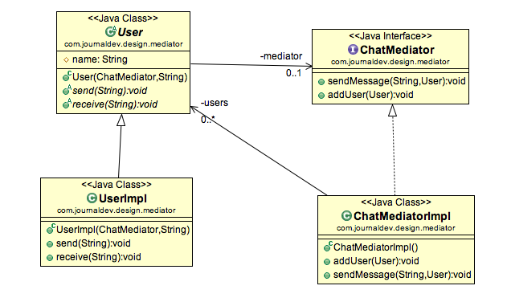
- Mediator Interface
Defines how users communicate.
public interface ChatMediator {
void sendMessage(String message, User sender);
void addUser(User user);
}

- Concrete Mediator
Manages users and routes messages.
public class ConcreteChatMediator implements ChatMediator {
private List<User> users = new ArrayList<>();

@Override
public void sendMessage(String message, User sender) {
// Send message to all users except the sender
for (User user : users) {
if (user != sender) {
user.receive(message);
}
}
}
@Override
public void addUser(User user) {
users.add(user);
}
}

- User Class
Users only interact with the mediator, not each other.
public class User {
private String name;
private ChatMediator mediator;

public User(String name, ChatMediator mediator) {
this.name = name;
this.mediator = mediator;
mediator.addUser(this); // Register with the mediator
}
// Send message via mediator
public void send(String message) {
System.out.println(name + " sends: " + message);
mediator.sendMessage(message, this);
}
// Receive messages from mediator
public void receive(String message) {
System.out.println(name + " receives: " + message);
}
}
- Demo
How it all works together:
public class MediatorDemo {
public static void main(String[] args) {
ChatMediator mediator = new ConcreteChatMediator();

User alice = new User("Alice", mediator);
User bob = new User("Bob", mediator);
User charlie = new User("Charlie", mediator);

alice.send("Hi everyone!"); // Bob and Charlie receive
bob.send("Hey Alice!"); // Alice and Charlie receive
}
}

Output:
Alice sends: Hi everyone!
Bob receives: Hi everyone!
Charlie receives: Hi everyone!

Bob sends: Hey Alice!
Alice receives: Hey Alice!
Charlie receives: Hey Alice!

Key Points:
- Loose Coupling: Users don’t reference each other—only the mediator.
- Centralized Control: The mediator handles all communication logic.
- Easy to Extend: Add new users without changing existing code.

Real-World Analogy:
Imagine an air traffic control tower. Pilots don’t talk to each other directly. They all communicate with the tower, which coordinates takeoffs and landings. This prevents chaos and reduces direct dependencies between planes.

Mediator Design Pattern Important Points
- Mediator pattern is useful when the communication logic between objects is complex, we can have a central point of communication that takes care of communication logic.
- Java Message Service (JMS) uses Mediator pattern along with Observer pattern to allow applications to subscribe and publish data to other applications.
- We should not use mediator pattern just to achieve lose-coupling because if the number of mediators will grow, then it will become hard to maintain them.

Resources:
https://chat.deepseek.com
https://www.digitalocean.com/community/tutorials/mediator-design-pattern-java

